How to install Zktech in odoo
- Install module
hr_zk_attendance
- Install pytz
  - Open cmd
  - Cd to: C:\Program Files\Python312
  - Install: Pip3.12 install zklib

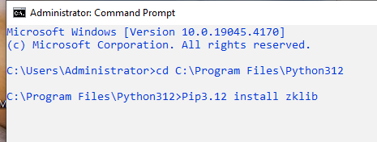
- Restart odoo service and test it

If error install: in venv, phycharm
- pip install numpy
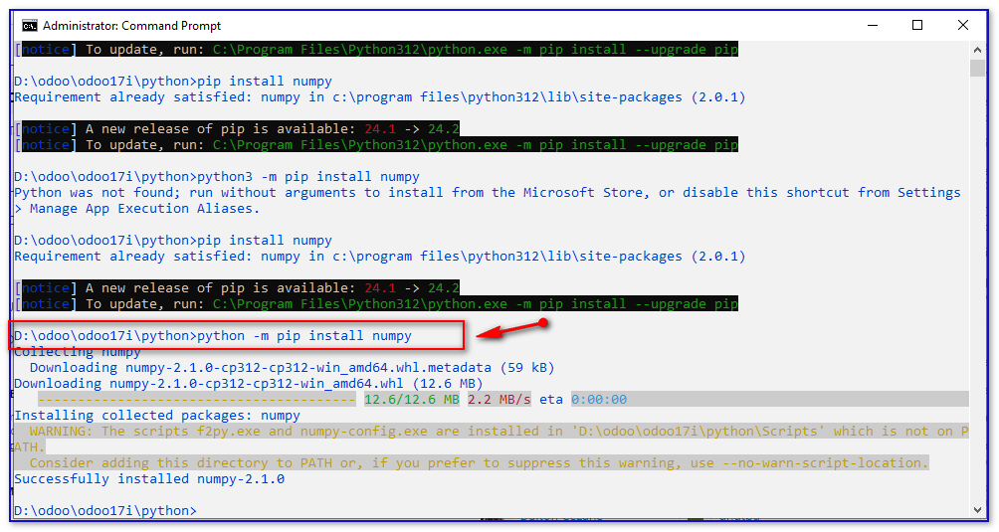
Fix error for odoo18:
Open cmd: python -m pip install Pyzk --upgrade
